Shapes and Colors
Red  Round | Blue  square | Light blue  Rectangle | Pink  Triangle
Purple  Oval | green  diamond | yellow  trapezium | Violet  dot
brown  pentagon | grey  hexagon | 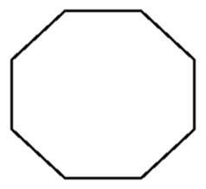  White  octagon | black  line
Orange  heart | Golden  star | Silver  crescent | multi-coloured  spot

