Good afternoon, ladies and gentlemen!
My talk will take about 5 minutes. During my presentation I will try to answer the one question: why the IKEA Company became successful?
I’ve divided my talk into four parts, four secret of the IKEA success.
I’ll try to answer all your questions after the presentation.
Now, let’s move to the first part of my talk, which is about the IKEA history.
Today, IKEA reaches millions of hearts and homes all over the world, but every success story has to start somewhere. Did you know that IKEA once was as a tiny business in Älmhult, a small Swedish village in the countryside, selling through a mail-order catalogue? And that the IKEA headquarters for design are still located there, in the middle of a beautiful landscape with forests, meadows and lakes? Here’s their story.
Ingvar Kamprad founded IKEA in 1943 at the age of 17, selling household goods like pens, wallets and picture frames. Småland, the landscape where Ingvar grew up, was stony and rugged. Back then, many of the inhabitants had to get by with small means, making as much as possible with next to nothing. Because of this, citizens are said to be thrifty and innovative, with a “no-nonsense” approach to everyday problem-solving. This heritage is one explanation for the IKEA way of doing things and to their success.
Moving on to the second secret – it’s The IKEA Concept. It starts with the idea of providing a range of home furnishing products that are affordable to the many people, not just the few.
“Why are beautiful products only made for a few buyers? It must be possible to offer good design and function at low prices.”
– Ingvar Kamprad
It is achieved by combining function, quality, design and value - always with sustainability in mind. The IKEA Concept exists in every part of company, from design, sourcing, packing and distributing through to business model. Main aim is to help more people live a better life at home.
Next secret it were the right sales technique. Älmhult, the town where IKEA was founded, is in a rather remote area of Sweden, and it was difficult to reach potential customers in the bigger cities. Due to this, the IKEA catalogue was born in 1951, and Ingvar had already decided IKEA should sell good furniture at low prices.
The prices in the first IKEA catalogue were so low that people were initially sceptical about the quality of the products, so Ingvar decided to convert an old workshop in Älmhult into a showroom where people could look at and try products before ordering. It was the first IKEA showroom.
Mail order distribution of bulky furniture was difficult and expensive, and products often got damaged. In 1956 we got the idea to take the legs off the table, which led to the idea of self-assembly and flat packing. It was revolutionary. A little table that contributed to a great idea.
Finally, we can’t imagine the IKEA without their products.
Let’s go back and remember the main idea of the IKEA production. Good home furnishing is for everyone. Everyone has the right to a better everyday life. They feel good design combines form, function, quality, sustainability at a low price. They call it “Democratic Design”. You can see it on slide.
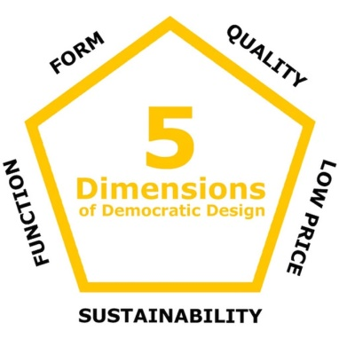

The Democratic design idea steers everything they do. By creating products that meet all five dimensions of Democratic design we will be unique - having a product range our customers and we feel proud of.
For them, good design is the right combination of form, function, quality, sustainability and a low price. Product developers and designers have to find the right balance of all these elements when the design process begins. It’s a challenge that keeps them innovative.
So, let summarize what I’ve said. Throughout their history, their best ideas have come from their biggest challenges, but they believe this is what makes them different. Respect to the history, concept, right sales technique and unique product made the IKEA one of the most well-known home furnishing brands in the world now.
I think you want to ask: What’s next?
IKEA is much too curious to wait around for trends to arrive. They prefer to ask themselves every day, “What can we do to make things better, so that everyday life will be better?”
The answer you can see on slide.
“Most things still remain to be done. A glorious future!”
Many thanks for your attention. Now I’ll try to answer any questions you may have.

